**Personal & Professional Development**

**2016/2017**

James Finglas

B00094138

B00094138@student.itb.ie

**Fractional Reserve Banking: A Modern Matrix**

Assignment 2 - Short Formal Report

Submitted 14th December 2016



I hereby certify that this material, which I now submit for assessment is entirely my own work. It has not been taken from the work of others save and to the extent that such work has been citied and acknowledged within the text of my work.

Signed: James Finglas

Date: /11/12

Student Number: B00094138

**Table of Contents**

1. Introduction/Summary 4

2. Origins 4

3. Mechanics 6

4. Deregulation…………………………………………………………….7

5. Discussion……………………………………………………………….8

6. Results/Conclusions…………………………………………………..11

Result's/Conclusions

References 12

**1. Introduction/Summary**

This report will layout the origins, basic inner working of; and consequences of FRB. The aim of the report is to provide a summary of how money passes through the FRB system and how the deregulation of the system has led to multiple market crashes in the global economy. The primary method of analysis was the researching of the document ‘Modern Money Mechanics” (1) and the impact of a major deregulation which occurred in the United States which set a global precedence which produced a ripple effect permeating through the global economy. Due to the nature of the scope of the subject material the report will be restricted to a general overview of the system. Furthermore, the report will layout the direct consequences of the system itself and deregulation.

**2. Origins**

‘FRB’ was introduced in 1913 under the Fractional Reserve ACT (1913) which was signed into law by then president Woodrow Wilson, which allowed for the creation of and issuance of currency within the United states. However, the origins of the system go back a little further to 1910. This was the year that several Prominent figures in business, banking and politics met in a place known as Jekyll Island in Glynn county, Georgia. The purpose of this meeting, as discussed in the book by G. Edward Griffin “The Creature from Jekyll Island” (2); was to lay out a plan to seize control of the issuance of currency from government to control monetary policy to further the groups aims (known as The Money Trust). It was at This meeting that the first draft of the fractional Reserve banking act was drawn up before it had even been proposed to then president Woodrow Wilson through the National Monetary Commission.

# 3. Mechanics

The mechanics of ‘FRB’ are of course very complex, starting with the creation and issuance of currency and the direct result of this is that ‘FRB’ also then governs the usage of money. These are the three factors in how the system controls money. However, to analyse the whole system as is far beyond the scope of this report so instead the report will analyse the system in its simplest form; a simple bank monetary deposit and what happens to that deposit once it enters the system.  
  
So, a client whom the report shall reference as client ‘A’ deposits 100 dollars into the system which is then credited to the clients account and the process begins. 10% of this deposit is held back as a capital reserve so that it may function as accessible money if there is a spike in demands for withdrawals, this is known as a run on the bank. This function is what gives rise to the term ‘Fractional Reserve’.  
  
The other 90% of the deposit is now considered to be available for new loans, if a demand for such loans exists. This 90% is then credited to the banks account and issued as a new loan to a new client whom the report will reference as client ‘B’. This new loan must then be repaid to the bank with interest which goes to the bank as profit. It is important to point out that once this new loan enters the system it is classed as new money and the cycle now repeats. So, the bank has essentially created new money out of nothing. This process creates inflation which is a hidden tax whilst also devaluing all other money which results in the issuance of more money from the Federal Reserve Bank (FED). A basic Diagram is presented in the results section to illustrate this Process (Diagram1).

## 

## 4. Deregulation

The Glass-Stegall legislation describes the four provisions of the US banking Act of 1933 that limited securities, activities, and affiliations within commercial banks and securities firms. These provisions prevented banks from directly investing in the stock markets. It also prevented banks from investing in or partnering up with securities exchange companies who directly affect the market share values of companies and commodities traded on stock markets.

The act was amended in 1935 to allow for direct investment via equity loans afforded to the security firms. This gave rise to massive over speculation on the part of the security firms who could now rely on loans to offset any incurred losses on the market.

The act was fully repealed in 1999, which should strike as a significant date as it is just two years before the total collapse of the worlds subprime mortgage markets and the collapse of major banks within the United states. The repealing of this act allowed for massive speculation in the derivatives and subprime mortgages by not just securities investment firms, but by banks themselves through their securities investment partners, which had previously been blocked by the Glass-Steagall act.

**5. Discussion**

It is important to understand that since money is first issued from The FED which must be repaid with interest, which makes the system a debt based system. Money is created from debt, and each time new money passes through the system it creates more new money further devaluing all money and creates a second layer of inflation. So, both the creation of money in the first instance and the create of new money from that money in the second instance constitute hidden taxes. And the devaluation of all currently existing money by the creation of money and new money constitute two more extra taxes via the reduction of purchasing power.

What the report Has shown from this investigation is that the process is a self-replicating cyclical cycle where the debt can never be repaid.

The report must now question the purpose of the system itself. How does the system benefit and how does government benefit from this system?

The government benefits as it gains the ability to borrow money from the FED without consulting the people they represent and without applying direct taxes. Prior to the FRB system coming into place governments balanced their cheque books prior to producing a budget which estimated the taxes required to be imposed upon the people. Now, with the FRB System in place, the government can borrow after the budget and pass the arguments about the deficit and increase in taxes onto the next government, or simply hide the reasons for the inflation, deficit and increasing taxes.

The banking side of the system gains on the commercial side of banking as it gains the ability to create new money without borrowing, or consulting the government. Furthermore, the bank is not required to hold any actual physical capital reserves or assets such as gold or silver as was the case prior to the FRB system. There is one further important gain, and it is the benefit that defines the system as a whole. The banks gain the ability to eliminate competition between themselves, because although each bank, including the Federal Reserve Bank are privately owned companies they are all complicate participants in the same system and as long as the system is in place they remain in power and profit and can prevent any new banks from outside the system from existing and/or competing with them. This is the very definition of a cartel and essentially makes them a law unto themselves.

# 6. Results/conclusions

A report produced by noted consultant and economist Frank Shostak in 2010 (3) preformed an in-depth analysis of the current state of world banking affairs which shows that the gradual deregulation has taken us to an inevitable decline in the state of the world economy. And in fact, that the system is not failing, it is doing exactly what it is designed to do as the system is based on the rapid expansion of the money pool. This in turn leads to bubbles forming in the markets and massive borrowing on the part of consumers. At the point the bubble bursts the money supply is contracted, wealth is redistributed from the poor to the wealthy and the cycle begins anew. This is both the purpose of the system and the cause of every major collapse since 1935 when deregulation began. This report concludes that the U.S. government and the Central bank entered into a mutually beneficial 3-tiered pyramid scheme, the greatest ever seen; that constitutes a hidden system of debt slavery that is fact working against the people of the world instead of serving it. Regulation of this system cannot fix it as it inherently flawed in conception, design, and implementation. The FRB must be dissolved and replaced with a more traditional form of deposit banking and we must reinstate strict regulation to keep banks and market speculators entirely separated.

Over-leaf you can see the diagram referenced in the main body which illustrates the passage of money through the system from the initial deposit.

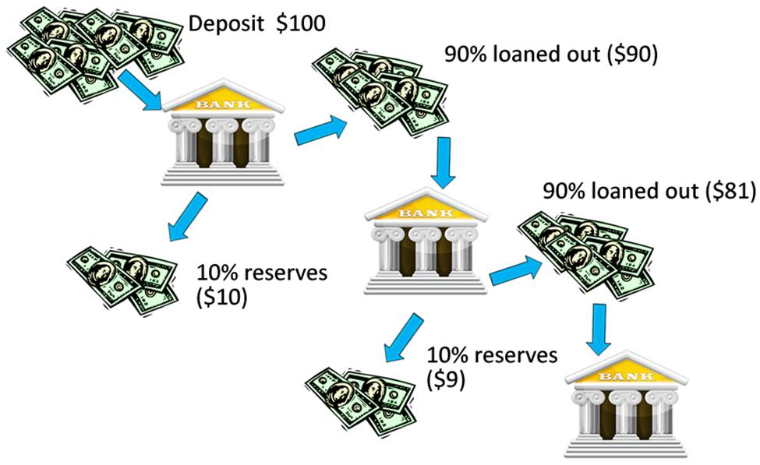

Diagram 1: Illustration of the passage of money through the FRB system. (1b)  
  
The chart displayed over-leaf displays the creation of money and the rate of savings which follow a corresponding curve. It highlights the fact that the peak points of money creation and savings also correspond with the great market crashes and depressions of the past 30+ years.

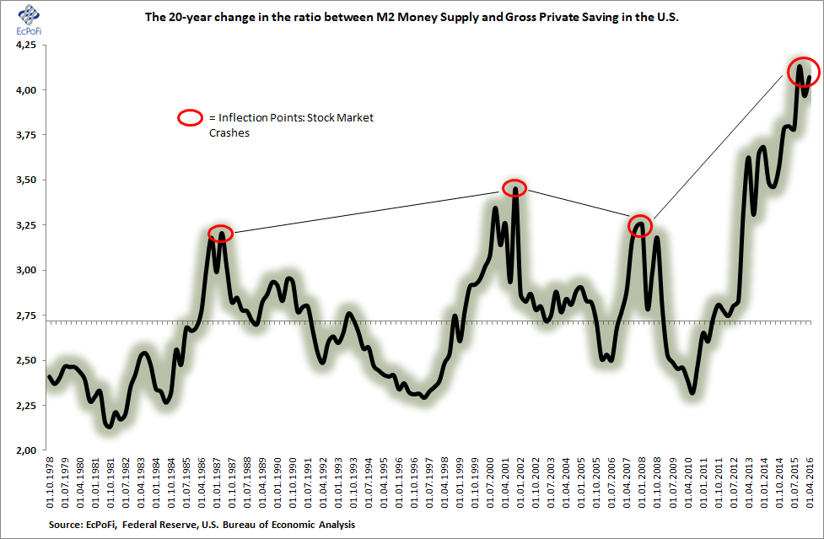

Chart 1: Money creation/savings chart, left shows money creation while the bottom shows the period with a curve displaying both money creation and savings. (1a)

**References.**

Primary reference material:

(1) The Public Information Centre of the Federal Reserve Bank of Chicago, “Modern Money Mechanics”, Chicago (1961).

(2) G. Edward Griffin, “The Creature from Jekyll Island: A Second Look at the Federal Reserve (1998).

(3) https://mises.org/library/does-it-make-sense-resurrect-glass-steagall-act , Frank Shostak – Mises Institute.org (2010).

Secondary Reference Material:

(1a) Image sourced from the Federal Reserve Bureau of economics.

(1b) Image sourced from hotpapermoney.com.